
ISLAMIC UNIVERSITY OF TECHNOLOGY (IUT)
ORGANISATION OF ISLAMIC COOPERATION (OIC)
DEPARTMENT OF ELECTRICAL AND ELECTRONIC ENGINEERING

EEE 4706
Microcontroller-Based System Design Lab

Project : DC Motor with speed control

Group Information:
Group No: 2
Section: A1
Group Members:

Student ID | Name
200021105 | Fabbiha Bushra
200021113 | Tasnia Nafs
200021133 | Syed Mohammad Ahnaf Faruk
200021141 | Mustafid Bin Mostafa
200021153 | Sheriffo Badjee

Mandatory features to be included

- Use the keypad to select clockwise or anticlockwise control, allowing the motor to rotate in the specified direction. Display the selected direction on the LCD.

- Add buttons for predefined motor speeds (LOW, MED, HIGH). By pressing a button, the motor will reach the corresponding speed. As the speed changes gradually, display the real-time RPM update on the screen.

- Simulate an overload protection system. If the motor exceeds a specified limit, activate a buzzer for alert purposes and turn the motor off.

Additional Features to be included

- Display the corresponding PWM (%): show the PWM level at which the motor is running, segmented into four levels:
  - LOW (25% PWM)
  - MEDIUM (50%)
  - HIGH (75%), and
  - Rated Speed (100%).
- ** 4 Specific LED will be there in order to distinguish between 4 Duty cycle (25%,50%,75% and 100%).
LCD flickering will denote each of the 4 cycle individually. If none of them is on/ Flicked at a time instant it will detect the error as it is not following none of the suggested Duty cycles, we generate.

Some common Questions:
(i) Why are we using a motor driver?
We are using 12V 2400 RPM dc motor.
- Voltage: 12 V DC
- Current: 201-300 mA

Ans: A motor driver is needed because microcontrollers typically can't directly provide the necessary voltage (0 to 5V) and current (3.2 mA peak) to power a motor. They are essentially amplifiers, taking low-power signals from a microcontroller and converting them into the higher power required to drive a motor. Motor drivers also control the motor's speed, direction, and other parameters, ensuring smooth and reliable operation. Motor drivers can also protect the motor from damage by limiting current, preventing overloads, and ensuring smooth operation.

Principle applied in L293D driver:
- H-Bridge Configuration:
Many motor drivers, especially for DC motors, use an H-bridge configuration to control the polarity of the current flowing through the motor, allowing for forward and reverse rotation.
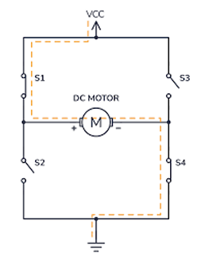
Specifications of L293D:

The L293D motor driver IC can handle output voltages ranging from 4.5V to 36V. It can also supply a maximum current of 600mA per channel, with a peak output current of 1.2A. The logic input voltage should be within the range of 4.5V to 36V

(ii) How can we control the direction of rotation using L293D driver?

Ans: IN1, IN2 pins are used to control the direction of rotation.

IN1 | IN2 | Rotation Direction
+ ve | -ve | Clockwise
-ve | +ve | Anti clockwise

Default direction of rotation of the motor in our project is clockwise.

To activate the driver EN1 pin must be set to high.
For anticlockwise rotation we need to press ‘*’ button of keypad and for clockwise ‘#’.

(iii) Mechanism for controlling Speed:

The most common technique used for speed control is PWM technique.
Pulse width modulation technique (PWM) is a technique for speed control which can overcome the problem of poor starting performance of a motor. PWM for motor speed control works in a very similar way. Instead of supplying a varying voltage to a motor, it is supplied with a fixed voltage value (such as 12v) which starts it spinning immediately.

The voltage is then removed and the motor ‘coasts. By continuing this voltage on/off cycle with a varying duty cycle, the motor speed can be controlled. The wave forms in the below figure to explain the way in which this method of control operates. In each case the signal has maximum and minimum voltages of 12v and 0v.

In wave form, the signal has a mark space ratio of 1:1, with the signal at 12v for 50% of the time, so the motor runs at half its maximum speed.

In wave form, the signal has mark space ratio of 3:1, which means that the output is at 12v for 75% of the time. So the motor runs at 3/ 4 of its maximum speed.

Similarly for 25% and 100%.
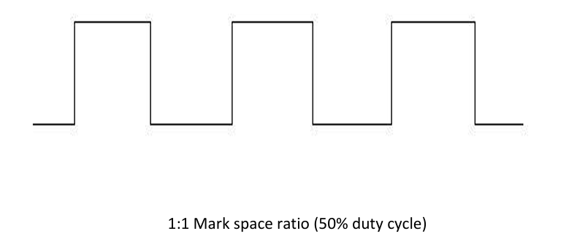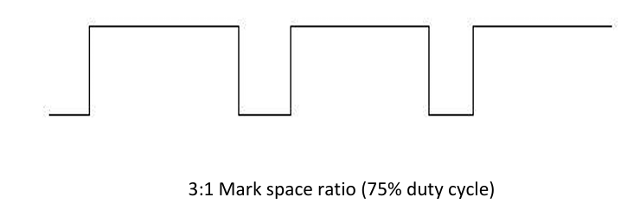
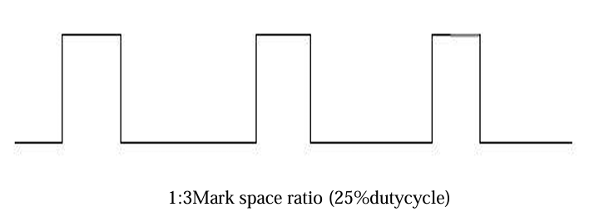

In code this is implemented by using a fixed delay and calling it as a ratio of 1:3 (25%), 1:1 (50%), 3:4 (75%) etc. For example-

SETB P1.4 Here Ton/Toff = ¼ so 25% duty cycle.
ACALL DELAY
CLR P1.4
ACALL DELAY
ACALL DELAY
ACALL DELAY

(iv) Overload protection:
Overload means due to excess load the motor will rotate at a very low3 speed. In our project we have implied the state when motor is running at 25% PWM as overload state as in this state speed is the lowest. So as a measure of safety after selecting 25% PWM level the motor will automatically go to off state and stop rotating. This is also overcurrent protection as well cause due to excess load motor will draw high current.

(v) Overspeed alarm:
When the motor is running at 100% PWM level that indicates no load or overspeed state. So as a precaution a buzzer will be turned on to notify and then we will manually stop the motor.

********* In proteus 8.17 12V buzzer is available. 5V buzzer is not included in the library. Since we are using 8.17 version so to operate the buzzer we are using this circuit.
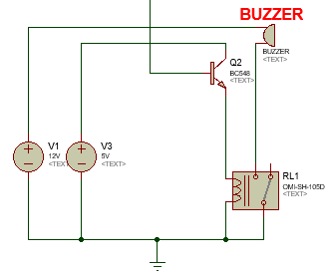

Here 12V is connected across the buzzer. Microcontroller is sending signal to the npn transistor. A 5v source is connected to the collector. When microcontroller sends signal to the transistor it turns on and subsequently turns on the relay. When the relay turns on buzzer gets 12V supply across it and turns on.

